Round 1:

[https://www.wane.com/top-stories/trump-puts-tariffs-on-canada-mexico-and-china-spurring-trade-war-as-north-american-allies-respond/](https://linkprotect.cudasvc.com/url?a=https%3a%2f%2fwww.wane.com%2ftop-stories%2ftrump-puts-tariffs-on-canada-mexico-and-china-spurring-trade-war-as-north-american-allies-respond%2f&c=E,1,no92nYjys_RNgMwm36zc1Vwyft4DtDl2GYiFdfeEGS-Yk7QnhIhlEEm2eAwzA8Rqj81CMTc1tisokemqWvd6faoiqV1_9Jvh1aiAGVGIdbzeUzLUT7E,&typo=1)

Round 2:

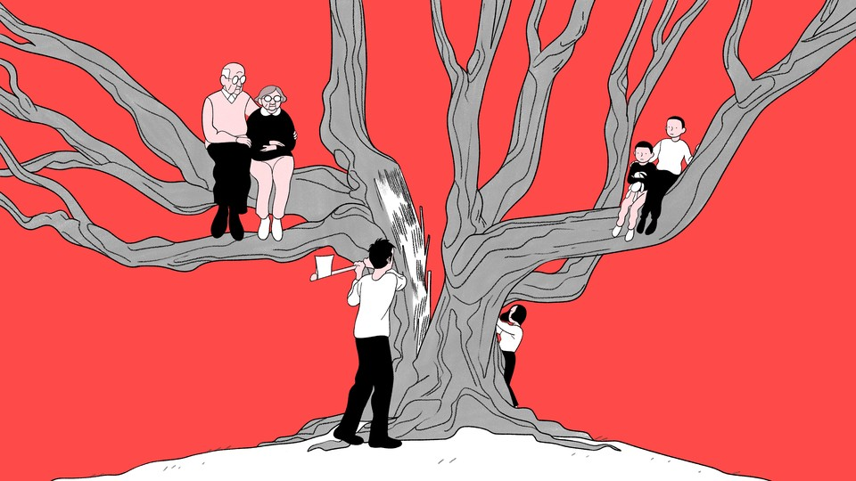

Bianca Bagnarelli

Round 3:

[Donors are down, but dollars are up – how US charitable giving is changing](https://theconversation.com/donors-are-down-but-dollars-are-up-how-us-charitable-giving-is-changing-246473)

Final Round:

<https://www.jpost.com/opinion/article-839999>